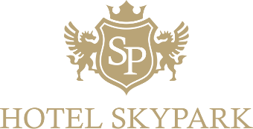
Reservation Requestㅇ

Attn : Kay
Email : 2038@skyparkhotel.com

Name of Guest * |  | Type of Room | □ Double □ Twin
No. of Guest * |  | Type of Room | □ Balcony Double
Add Breakfast ** | □ Yes □ No
Check-in Date (yyyy-mm-dd) |  | Check-out Date (yyyy-mm-dd)
Guest E-mail |  | Guest Phone no.
Credit Card No. |  | Expiry Date (mm/yy)

* In case of a double occupancy, all guest names should be given in this form for the Hotel Reservation information reference purpose only.

** Upon reservation request or upon check-in, guests can add breakfast at a discounted price of 23,100 won per person and per day. It is applicable only when breakfast is added in advance for the full length of stay and not applicable for intermittent days. Otherwise, 26,400 won will be charged.

Hotel Skypark Kingstown Dongdaemun
14F, 20, Jangchungdan-ro 13-gil, Jung-gu, Seoul, Korea / Postal Code : 04563
Website ; Go to the Hotel’s English Website
Mail : 2038@skyparkhotel.com / 2511@skyparkhotel.com

[HOTEL INFO]
- Check-in: After 3PM / Check-out: By noon
- Children aged over 6 is charged same with adult fare.
- It is not allowed to add extra bed and extra occupants.
- Each floor has a fully equipped public kitchen
- Smoking is prohibited within the guest room.
Please use designated smoking area(section).
Reservation Requestㅇ

[Cancellation Policy]
Free changes and cancellations are allowed by 15:00 PM 7 days prior to check-in date. A penalty of one night’s rate will be charged for late changes & cancellations and No-Shows (subject to 10% VAT).

